**--------------------------Basic Authentication----------------------------------**

**https://www.youtube.com/watch?v=oZRVkdbEyfM**

Spring Security's basic authentication is a simple and straightforward method for authenticating users by sending their credentials (username and password) with each request.

When you add security dependency spring is configure with default login page with username=user and password is generated on console.

When we write WebSecurity configure and override function it enable httpBasic security which shows pop-up window for user name and password

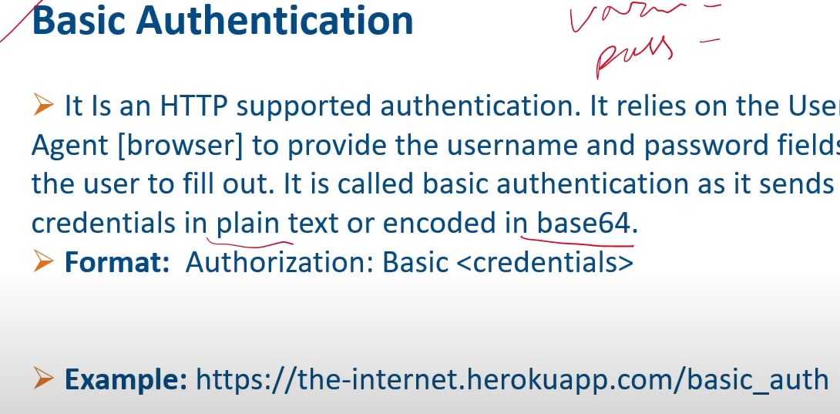

---------------------Digest Authentication-------------------------

Digest access authentication is one of the agreed-upon methods a web server can use to negotiate credentials, such as username or password, with a user's web browser. This can be used to confirm the identity of a user before sending sensitive information, such as online banking transaction history.

Digest Authentication tries to solve many of the weaknesses of Basic authentication, specifically by ensuring credentials are never sent in clear text across the wire. Many browsers support Digest Authentication.

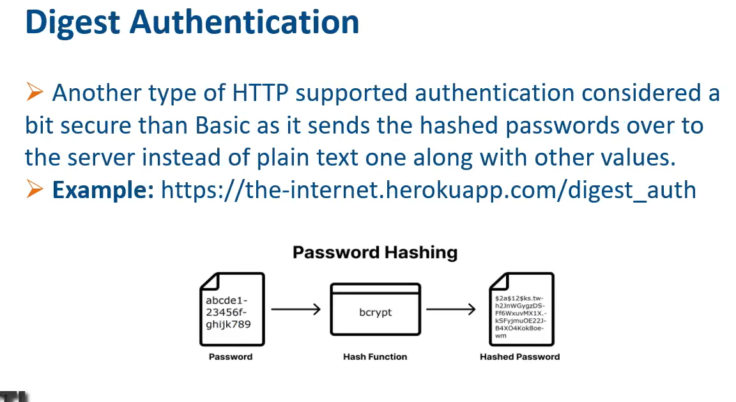

**------------------------Bearer Token-Authentication------------------------**

These are the terms we need to address:

* **Authentication** refers to the process of verifying the identity of a user, based on provided credentials. A common example is entering a username and a password when you log in to a website. You can think of it as an answer to the question *Who are you?*.
* **Authorization** refers to the process of determining if a user has proper permission to perform a particular action or read particular data, assuming that the user is successfully authenticated. You can think of it as an answer to the question *Can a user do/read this?*.
* **Principle** refers to the currently authenticated user.
* **Granted authority** refers to the permission of the authenticated user.
* **Role** refers to a group of permissions of the authenticated user.

